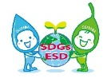
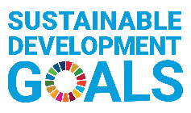
Okayama ESD Award 2026
－Application Form (for Draft)－
- This format is for drafting only. Please copy and paste what you have written in this form into the online Application Form.
- Please follow the word limit in each column, where indicated. When applying online, you cannot enter text that exceeds the specified word count.

- Information about Your Organization <Required> (Please use extra space if needed.)
Name of Organization
※For universities, please include the name of the department.
Name and Job Title of Representative of Organization | Name:  (Job Title: )
Street Address of Headquarters  (including Postal Code) |  | Country
Telephone Number
URLs of Website/ Facebook
Name and Job Title of Contact Person | Name:  (Job Title: )
Email Address of Contact Person
Category of Organization | Please check one category that best describes your organization.
Category of Organization | ☐ School, University  ☐ NGO, Civic Group  ☐ Local Group, Community Learning Centre (CLC)  ☐ Business  ☐ Others (Please specify: )
Description of Organization | Please provide a summary description of your organization, in detail. 【max. 150 words】

- Information of Your Project <Required>

- Name
of Project
- Project Summary | Please provide a summary of your project including specific goals, key components and activities, outputs and expected outcome, in detail. 【max. 300 words】
- Project Summary | Please write the URL of the project’s website if there is one.
- Vision | Please describe goals and objectives of the project to overcome the challenges faced by local communities in achieving a sustainable society, in detail. 【max. 300 words】
- Basic Information | Duration | Started in (month/year) | ( / ) ※The project should be ongoing and have been running for at least three years as of April 2026. (The starting date must be before March 2023.)
- Basic Information | Duration | If this project continues in the future, please check the box of “Continue”, and if you have a definite plan to terminate the project, please write the termination date (month/ year). | Continue ☐  Termination Date ( / )
- Basic Information | Beneficiaries | Location(s)  (City/Country)
- Basic Information | Beneficiaries | Beneficiaries
- Basic Information | Beneficiaries | Number of Beneficiaries | about ( ) persons
- Basic Information | Annual cost | Annual cost of the project | about ( ) US Dollars/ per year
- Basic Information | Funding source(s) | Please explain the funding source(s) of the project, such as subsidies, donations, public funds, etc.
- Collaboration | Please describe the implementation system, including the structure of the collaborating groups and organizations and the rolls of each entity, in words, in detail. If you would like to submit diagrams, you may do so in Word or PDF format as a supporting document in the "5. Other Supporting Documents (Optional)" section. (The resolution must be legible.) 【max. 300 words】
- Integration | Please describe how the project integrates economic, environmental, and social dimensions of sustainable development, in detail. 【max. 200 words】
- Innovation | Please describe how the project demonstrates innovative approaches and method to ESD, in detail. 【max. 200 words】
- Status of Implementation | Please describe the following two points, in detail:  ・Quantitative data such as the total number of project participants and organizations, results of participant surveys, etc.  ・Objective evaluation such as feedback from participant questionnaires, articles and news coverage, and awards received to date. 【max. 300 words】
- Empowerment | - Please describe the kinds of educational approaches that the project is using, such as interactive learning for problem-solving and/or participatory practices, in detail.  【max. 400 words】
- Empowerment | - Please describe achievements of the project and ways to disseminate the results, such as how the project brought behavior change among the targeted groups including the transformation of values, attitudes and actions, and empowered local communities, in detail.  【max. 400 words】
- Future Strategy | Please describe how you are planning to develop and expand the project in the future. Please also include the information such as any strategies, expected target groups, expected project duration and budgets per year, in detail. 【max. 200 words】

- Contribution to the Sustainable Development Goals (SDGs)※ <Required>
To which SDG goal(s) is (are) the submitted project related?
※Please refer to the United Nations website about the SDGs. (http://www.un.org/sustainabledevelopment/)
- Please check all SDG goals related to the submitted project. (Multiple answers allowed.)
☐ 1 No Poverty  ☐ 2 Zero Hunger  ☐ 3 Good Health and Well-Being  ☐ 4 Quality Educationon  ☐ 5 Gender Equality  ☐ 6 Clean Water and Sanitation  ☐ 7 Affordable and Clean Energy  ☐ 8 Decent Work and Economic Growth  ☐ 9 Industry, Innovation and Infrastructure | ☐ 10 Reduced Inequalities  ☐ 11 Sustainable Cities and Communities  ☐ 12 Responsible Consumption and Production  ☐ 13 Climate Action  ☐ 14 Life below Water  ☐ 15 Life on Land  ☐ 16 Peace, Justice and strong Institutions  ☐ 17 Partnerships for the Goals
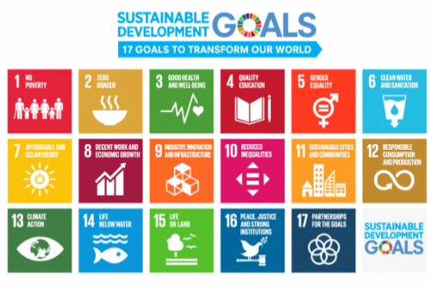
- Which SDG goal is most relevant to the submitted project? (Select One)
- Please describe how the submitted project relates to one or more of the SDGs. 【max. 200 words】
- A Video / Slideshow or Photos as an Alternative to Introduce the Project <Required>
Please make one video or slideshow of the project (5 minutes or less), upload it on YouTube or Facebook, and write the URL.
- URLs from Google Drive or other compressed files are not accepted.
If you have difficulty to make a video or slideshow, you can instead submit photos (at least 5 and up to 10) in JPF (JPEG), TIFF, or BMP format.

URL of a Video or a Slideshow

- Other Supporting Documents <Optional>
You can submit relevant supporting documents in a single file of no more than five pages (A4 Size) in Word or PDF format. Any pages exceeding this limit will not be considered in the review process.

